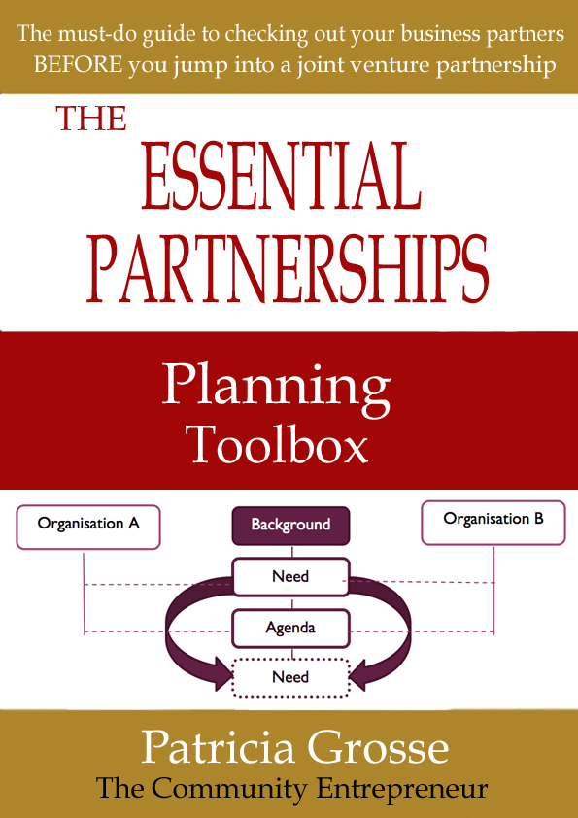
THE
ESSENTIAL
PARTNERSHIPS
TOOLBOX
Your guide to checking out your business partners BEFORE you jump into a partnership venture
Managing Change
Managing Change
Your partnership venture may require organizational change and/or compromise. You may be involved in adapting or creating new systems to accommodate the new venture. It may not be a smooth journey and there could be a number of barriers to change that must be overcome, especially if you or your partner(s) employ staff, including:
- Culture – organisations have their own habits and belief systems
- Rebellion - there could be at least one person who may not like what’s happening and may try to undermine change
- Fear – not understanding what’s going on, fear of losing job, fear of change
- Finances – how much is this going to cost us?
- Loss of control – we are autonomous!
- Lack of expertise – how can we make decisions when we don’t know what to look for?
- Lack of communication – what’s going on?
- Low levels of trust – who are these guys telling us what to do? Why should we work with them – they’re competition?
- Where are these people going – it’s not what we want to do?
A well thought out and implemented Change Management Plan could help to reduce the barriers and assist with achieving the desired outcomes.

The Change Management Plan
The Change Management Plan could look like this:

Step 1 – Purpose and Need
The partners work through the Proposition and Framing your Agreement stages and develop the Strategic Direction for the partnership that is endorsed by the ALL partners. The Strategic Direction will incorporate a common Vision, what needs to change to achieve the Vision and how change will occur. This will be signed off by all the partners.

Step 2– Leadership
Partners may delegate management of the project and channels of communication. Those guiding the partnership venture should have enough power or influence to lead the change program. This could be the managers on the day-to-day level and a group representing the owners providing oversight if the venture impacts at the governance level. Otherwise the managers should report directly to their individual business owners (if it isn’t the owners themselves). Is there an agreement on one person with overall operational responsibility (to prevent confusion)?
The partners should agree that there are circumstances where the people with delegated authority cannot be undermined. There may be staff who do not like a decision who may go directly to a higher authority to state their case. If this should occur, the person concerned must be referred back to the manager concerned.
The leadership team should also be aware of ill-informed people or people wanting to undermine the project, who will try to divide the leadership through misinformation or through an identified difference of opinion in the leadership group. The leadership group should keep in regular contact to minimise these risks.

Step 3 – Communication
It is a good idea to develop a communique for managers to provide to staff explaining the rationale and need for the change. Explain in detail the partnership Vision, goals and priorities. Incorporate visuals if possible. People may already have concerns. If necessary, take these concerns on notice and feedback through the designed communication channels.
A Communication Plan developed for and between each partner could help to explain to everybody how the change process will work and how they can feed into the process etc. The aim is to ensure that everybody is clear about levels of responsibility and reporting lines.
It is helpful to organise weekly meetings to update people on progress.

Step 4 – Cooperation
Encourage people to come forward with ideas that could help to achieve the new direction. Show them how these ideas may be incorporated into the new direction.
It may be worthwhile engaging staff in the change process as long as they are not trying to sabotage the change.

Step 5 - Evaluation
Include staff in the internal evaluation of new templates, resources and processes. They may be able to assist with the identification of strengths, weaknesses and risks and streamlined systems.

Step 6 - Recognition
Developing short term plans with staff may assist them through the change. Use these plans to identify and recognise short term gains. These could be included in individual performance plans and professional development records.

Step 7 – Maintain the momentum
Communication is important so keeping staff up to date, even when nothing seems to be happening, helps to maintain the momentum and prepare them for the next step in the plan.

Step 8 – the new world order
If the beginning of the change process identified the need for change and the potential benefits of changes, by this stage, those benefits should be clearly achieved to each partner. This is the new world order.
However, if the benefits are not clear at this stage, why are they not clear? Has the evaluation identified reasons for a different outcome?

Step 9 - Celebrate
Finally – CELEBRATE! Acknowledge the achievements of everybody involved should also empower them to ‘own’ the new situation.

Change Management Templates
A set of useful resources to help guide you through a change management process associated with organisational change where staff are involved.

Change Management Plan
Draft a plan and process considering the following:

STEP | ACTIONS
Step 1 – Purpose and Need | Are the partners clear about the need for and purpose of, the venture?  Have the partners developed a Strategic Plan for the change project?  Are the partners clear about the Vision, Objectives and expected Outcomes?  Does this Plan incorporate Risk Management strategies?
Step 2 - Leadership | Who is the Change Manager?  What roles do the partners  have in the change process?  Is there a change management team?  Are the partner representatives fully briefed  and engaged in the change plan?  Does everybody understand the boundaries  of their roles and responsibilities?
Step 3 – Communication | Has a communication plan been agreed and documented for the change project?  Does this plan (including the Vision and strategies) have visuals (for people to grasp and remember)?  Has a communique been developed to be used by all partners to communicate the project to all concerned?  Have regular meetings between partners been planned up front?  Are partners planning a calendar of meetings with their staff, volunteers and stakeholders throughout the change project?
Step 4 - Cooperation | What have you put in place to encourage people to get involved in the change process:  Ideas?  Actions?  Feedback?
Step 5 - Evaluation | Do you have an evaluation plan (to measures the  success of the change process?  Is the evaluation plan being implemented?  How are staff involved in the evaluation?  Have you benchmarked current systems and processes?
Step 6 – Recognition | Have you developed short term plans with your staffto assist them through the change process?  What have you got in place to celebrate short term successes?

Step 7 – Maintaining the momentum | Are you maintaining your communication with staff– documented? (even when nothing appears to be happening)  If you are falling behind, is there anything that can be organised to assist in bringing things up to date?
Step 8 – The New World Order | Have you achieved the outcomes you expected?  Have you carried out an end of the change project (summative) evaluation of the outcomes of the change project?
Step 9 – Celebrate | How are you going to celebrate?

Change Enablers
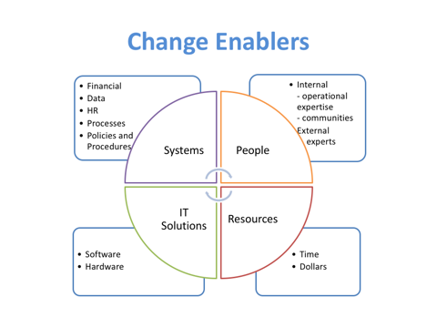

Change enablers support the change process. They include:

People
Partnership ventures especially those that lead to change, can be assisted by the relevant external expertise. This can be in the form of an independent project manager/change facilitator and/or specialist expertise as required eg HR or IT consultants.
Although there is a cost involved, bringing in external expertise saves time in learning skills and also allows all partners to be equally involved.

Resources
Resources can be time, funds and research.
Projects and change activities may not be able to achieve the outcomes if insufficient time has not been allocated to the project and to the staff involved in the project.
Access to a budget is a change enabler in that it can be used to purchase people, time and physical resources, as well as pay for incidental costs such as travel, and professional development.
Research is a change enabler because it documents what others have experienced before – what works, what doesn’t. Carrying out background research and applying to the current situation should eliminate a lot of time and energy and help the project to move forward quickly.

IT Solutions
There are a plethora of software and project management tools available today that will assist with communication, managing the project, meetings and collaborating online. Whole projects can be managed within a single program to which all invited stakeholders will have varying levels of access. Keeping all documentation in one place (backed up regularly) ensures that the project is efficiently recorded.

Systems
Once in place, common systems eg financial, HR and IT, as well as processes lead to structural change (changes the way authority, finances, information and responsibility flow within and across the organisations).

Change Enablers
Have you got in place enablers that support change?

Change Enablers
People | Partnership Change Manager  Staff with appropriate skills  External expertise (if required)  __________________________________________  Change mentor (optional)  __________________________________________  Specialist support (eg HR, IT, accountants, lawyers)  __________________________________________  __________________________________________
Resources | Budget and access to funds  Sufficient time to achieve the milestones and  to complete the project  Research/market data  Other  __________________________________________
IT Solutions | Compatible IT infrastructure  (may involve an audit of infrastructure)  Online communication platform  Online record sharing platform  Appropriate levels of password access and permissions  Secure backup and storage of information  System for maintaining currency/version control
Systems | HR / Performance management  ___________________________________________  IT solution (eg website, database, record keeping)  ___________________________________________  Financial bugeting, record keeping and reporting  Policies/Procedures and/or Processes  ___________________________________________  Other  ___________________________________________

Once you have a Change Management Plan and processes in place, don’t forget to evaluate its contribution to efficiencies, effectiveness and success factors.

The Sharing Services Module focuses on the process of integrating processes and systems that may be required as part of a partnership venture. Use this module in connection with the Managing Change module as an additional resource for effective change planning.

