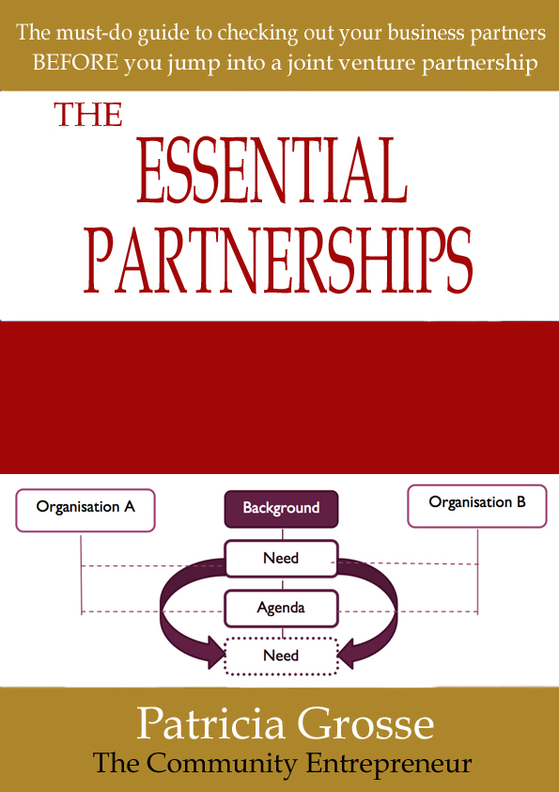
THE
ESSENTIAL
PARTNERSHIPS
TOOLBOX
Your guide to checking out your business partners BEFORE you jump into a partnership venture
Framing Your Agreement

Framing your Agreement

To prepare your partnership venture to succeed, consider the following:
- The partnership venture is of mutual benefit
If you do not think you will get benefit from this partnership venture, why are you still at the table?
- An agreement by all partners to participate
If a partner is reluctant or stalling for time, there may be something wrong. Don’t go ahead automatically assuming they will sign on the dotted line.
- The proposed venture fits with your strategic/business plans
If it doesn’t fit with the vision and directions of partner, your partnership may be is at risk when circumstances change. What you are doing is not a ‘nice to have/do’, it should address a business need. Does your business plan incorporate your partnership venture?
- A plan has been prepared and agreed by all partners which details the contribution of each partner and the resources and time required of each partner
Get this signed at the highest level to ensure commitment
- Agreement of the financial investment required of each partner
This will include accountability, financial reporting arrangements and financial arrangements at the end of the partnership
- Agreement by senior management of all partners to support the partnership venture– this involves understanding what is required as well as the benefits and risks involved
With senior level sponsorship, it is easier to get traction
Once the partnership has been set up, staff from the partners may be nominated to be the spokespersons for the partnership activities. These may not be the same people who agreed to collaborate so they may have a different understanding of the purpose of the partnership, the deliverables, the outcomes and who does what. Especially if the key personnel don’t have a prior relationship, it will be fundamental that they develop trust and commitment. If trust does not exist or there’s a negative history between at least two of the participants or the businesses they represent, the key to success may be to go through a process to reach a common understanding and to get at least the following elements into writing:

- A common Vision
- Agreed, clearly articulated Objectives and Outcomes
- Understanding of roles and responsibilities
- Detailed outline of tasks and expected contributions from partners
- Partnership Agreement.

A Common Vision
The Vision, Objectives and Outcomes may have already been written into the Partnership Agreement. If this is the case, then the delegates’ representatives from each partner should revisit these as early as possible once the partnership venture begins. It may be worthwhile creating two posters or A4 size sheets, one with the Vision and the other with the Objectives and Outcomes. These can then be displayed somewhere they can be easily viewed as a reminder of what the partnership is about. Without constant reminders the Vision may become blurred. The Outcomes anticipated at the start of the venture may not be the outcomes achieved by the end.

Agreed, clearly articulated Objectives and Outcomes
From the Vision comes the Objectives (goals) which inform the Outcomes (consequences). When partners are from diverse interests, individual objectives may not be appropriate to every partner. Whilst it is an advantage to be aware of these objectives, it may be less complicated if the project were to focus on mutually agreed objectives. To achieve this may require initial trust by partners agreeing only on the common Objectives.
The expected Outcomes are dependent on getting an agreed and understood set of Objectives.
The implications of trying to accommodate everybody’s objectives may be detrimental to the project later on. It may be advisable to start with adopting only the Objectives that fit with all partners.
Once the Vision and Objectives have been agreed, the partners should in a position to develop a business strategy to achieve the outcomes.

Understanding roles and responsibilities
If not clearly documented and understood at the start of the partnership venture, lack of clarity around roles and responsibilities may lead to confusion, misunderstandings and resentment. This can be multi-level within and between the partner businesses.
Partners may have agreed to the collaborative venture based on the assumption that others could provide the resources, skills and/or networks that they don’t have access to. At this stage, an assumption may be all some partners have. There are two possible points in the initial partnership meetings where assumptions begin to take the shape of understanding. The first point may be when each potential partner talks about who they are, what they do, and what they expect from the joint venture.
The second point is when they start to put together a plan. A well-facilitated process should allow the partners the opportunity to put their expertise, access to resources and availability onto the table. The person appointed to lead the venture should use this as an opportunity to build relationships with the potential partners.
For a business-to-business partnership, it may be advisable to be clear about who is in charge of what. If you are not clear, any number of unwelcome scenarios can arise including:
- One partner assumes control. The second partner allows this to happen in the first instance but then becomes aggrieved as their own authority is undermined.
- No partners takes control – nothing gets done or what does get done is uncoordinated and ineffective. It may be an agreed strategy in the interest of collegiality but over time frustrations may come to light where the partnership lacks leadership.
- A partner could be out of their depth by taking on a role they are not expert in.
Through working together on the Partnership Business Case Plan, the partners will be able to agree their roles and responsibilities.

Detailed outline of tasks and expected contributions from partners
Once the partnership plan is developed and agreed a priority may to detail the tasks and contributions of the partners. Where finance is involved, this may also include budget implications. All partners should be committed to contribute to the level agreed in the business plan.
When it comes to partnership joint ventures, other priorities outside of the joint venture may take over the priorities of a partner. In these situations, the temptation may be to withdraw commitment and resources from those activities that are no longer seen as a priority or need. Partners may be very enthusiastic in the first instance, but may back off when the commitment extends their availability or resources. Others may be too enthusiastic or personalities may become an issue.
In some partnerships, lack of structure and systems may be compensated by strong personal relationships. Many partnership ventures involve pre-existing relationships and are planned around the continuation of these relationships. However, circumstances may change and the relationship building may have to start again. The dynamic may change considerably. Changing one key person integral to the contribution to the partnership venture may significantly set the partnership backwards.
Another reality emerges when the friendship that two business partners who seemingly got on very well prior to the partnership, does not survive the partnership. Possible reasons for this are explored in the Tips for Successful Partnerships section.

To avoid the worst of the impact of changes to personnel, it may help if the tasks and contributions from partners are documented and monitored. A person taking over the role may have a better understanding of their role in the partnership venture and progress to date. This shoukd also relate to the common Vision, Objectives and expected outcomes.

Partnership Agreements
Underpinning the Vision, objectives, outcomes, roles and responsibilities and tasks, is the written agreement. This document may include (but not limited to):
- Name of project or collaboration
- Timeframe and milestones
- Names and details of partners
- Key contact personnel
- Purpose of Agreement
- Objectives, deliverables and outcomes
- Strategy/business plan (or intention to develop and agree a plan)
- Roles and responsibilities of each partner to the agreement
- Ownership of Intellectual Property and Copyright
- Financial details including arrangements for payments and distribution of profits if applicable
- Indemnity and other insurances
- Reporting arrangements
- Dispute resolution arrangements
- Arrangements for renegotiation of agreement
- Exit strategy / plan including financials, customers and intellectual property
- Termination of agreement conditions
- Exploitation and ownership of outcome
- Signatures and dates – signed by people with delegated authority within the organisation.

The Partnership Agreement may provide some assurance in the event of a change of circumstances or any other variations to the original plan and commitment by any or all concerned.
The Agreement should be signed before any significant work is carried out.
Unfortunately, it can be so easy for the development and signing of the Partnership Agreement to get overlooked to the point it gets left and may not get signed at all.
When there is a problem, partners then realise the significance of having a signed agreement in place. The signed agreement should be negotiated with formal legal advice.

Partnership Checklist for Collaborative Activities

Partnership Checklist
Title of the venture/activity
Timeframe
Partners (names of businesses involved) and names of senior representatives
Lead Partner (if designated)
What is the mutual benefit(s) to all partners? | Should apply to all partners – all will have varying degrees of benefit, but there will be at least one underlying benefit
Has an agreement been signed by all partners? | Authorised personnel ONLY of all partners should sign an Agreement – this will ensure top level buy-in into the venture  Yes / No
Does this venture fit with the strategic/business direction of each partner? | Yes / No
Do the budget projections appear to be realistic? | Yes / No
Is there a plan in place that details the contributions of the partners to the joint venture/activity?  Tasks?  Funds?  Resources?  Time?  Infrastructure? | This plan should be attached to the Agreement/MOU.  Yes / No  Yes / No  Yes / No  Yes / No  Yes / No

Commencement Checklist
The questions in this section should be revisited by the partners on commencement of activities.
The information may be derived from the legal partnership agreement or it may be used to inform the Partnership Agreement.

Commencement Checklist
What is our common vision for this project?
What are the partnership objectives? | Can be cross-referenced with the original proposal – all partners must be clear about the common objectives (may have their own objectives)
What are the expected outcomes? | Can be cross-referenced with the original proposal – the final outcomes may differ
What are our individual roles and responsibilities?
Are we clear about our tasks and contributions?
Do we have a communication plan in place?
Are there any changes that need to be made?
If so, what?

Summary

- Some conditions for a successful partnership venture
- Vision, Objectives and Outcomes
- Roles, responsibilities and contributions from partners
- Elements of the written agreement
- Partnership checklist for joint venture activities
- Commencement checklist

So far we have explored ideas for putting together a Business Case for a partnership, as well as factor to consider and include in your partnership agreement. These are factual elements of a partnership that can be articulated and used to keep the partnership focused.

But what about the intangibles? The ‘soft’ drivers that can make or break the joint venture?

Check out the five foundation stones that determine the success of a partnership from the inside out – “Foundations of Collaborative Partnerships”.

